Car Customization and Option Display

Create a program that allows users to customize a car build and prints all the selected options. The user will provide input via standard input, and the output will be displayed on standard output.

**Car Manufacturer:**

* Mahindra
* Tata
* Maruti

**Model (for Mahindra):**

* Scorpio
* Thar
* Scorpio N
* XUV 700

**Transmission Variant:**

* Manual
* Automatic

**Fuel Type:**

* Diesel
* Petrol
* CNG

**Accessories:**

**Color**

* Silver
* Blue
* Yellow

**Location:**

* Delhi
* Bangalore
* Hyderabad
* Chennai

package assignment;  
  
import java.util.*;  
  
class Car {  
 private String manufacturer;  
 private String model;  
 private String transmission;  
 private String fuelType;  
 private String color;  
 private String location;  
  
 public Car(String manufacturer, String model, String transmission, String fuelType, String color, String location) {  
 this.manufacturer = manufacturer;  
 this.model = model;  
 this.transmission = transmission;  
 this.fuelType = fuelType;  
 this.color = color;  
 this.location = location;  
 }  
  
 public void displayOptions() {  
 System.*out*.println("\n--- Car Customization Summary ---");  
 System.*out*.println("Manufacturer: " + manufacturer);  
 System.*out*.println("Model: " + model);  
 System.*out*.println("Transmission: " + transmission);  
 System.*out*.println("Fuel Type: " + fuelType);  
 System.*out*.println("Color: " + color);  
 System.*out*.println("Delivery Location: " + location);  
 }  
}  
  
class ModelSelector {  
 private static final Map<String, List<String>> *modelsByManufacturer* = new HashMap<>();  
  
 static {  
 *modelsByManufacturer*.put("Mahindra", Arrays.*asList*("Scorpio", "Thar", "Scorpio N", "XUV 700"));  
 *modelsByManufacturer*.put("Tata", Arrays.*asList*("Nexon", "Harrier", "Safari", "Punch"));  
 *modelsByManufacturer*.put("Maruti", Arrays.*asList*("Swift", "Baleno", "Brezza", "Dzire"));  
 }  
  
 public static List<String> getModels(String manufacturer) {  
 return *modelsByManufacturer*.getOrDefault(manufacturer, Arrays.*asList*("Standard Model"));  
 }  
  
 public static boolean isValidModel(String manufacturer, String model) {  
 List<String> validModels = *getModels*(manufacturer);  
 return validModels.contains(model);  
 }  
}  
  
public class CarCustomization {  
 public static void main(String[] args) {  
 Scanner scanner = new Scanner(System.*in*);  
  
 System.*out*.println("Select Car Manufacturer (Mahindra / Tata / Maruti): ");  
 String manufacturer = scanner.nextLine();  
  
 List<String> validModels = ModelSelector.*getModels*(manufacturer);  
 System.*out*.println("Available models for " + manufacturer + ": " + validModels);  
 System.*out*.println("Select Model: ");  
 String model = scanner.nextLine();  
  
 if (!ModelSelector.*isValidModel*(manufacturer, model)) {  
 System.*out*.println("Invalid model selected. Assigning default model: " + validModels.get(0));  
 model = validModels.get(0);  
 }  
  
 System.*out*.println("Select Transmission Variant (Manual / Automatic): ");  
 String transmission = scanner.nextLine();  
  
 System.*out*.println("Select Fuel Type (Diesel / Petrol / CNG): ");  
 String fuelType = scanner.nextLine();  
  
 System.*out*.println("Select Car Color (Silver / Blue / Yellow): ");  
 String color = scanner.nextLine();  
  
 System.*out*.println("Select Delivery Location (Delhi / Bangalore / Hyderabad / Chennai): ");  
 String location = scanner.nextLine();  
  
 Car customizedCar = new Car(manufacturer, model, transmission, fuelType, color, location);  
 customizedCar.displayOptions();  
  
 scanner.close();  
 }  
}

Output:

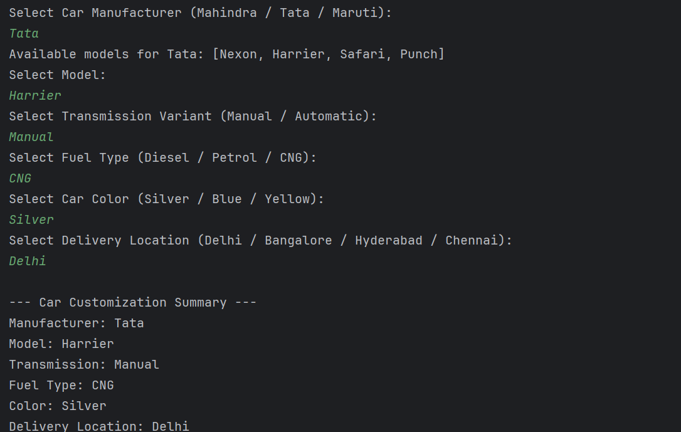

Problem Statement: Tax Calculation

Write a program to calculate the annual tax owed by an individual based on their salary, age, and other parameters. The user will input their details, and the program will output the total tax amount.

**Parameters:**

1. **Salary (in INR):**
   * 1. Annual salary of the individual.
2. **Age (in years):**
   * 1. Age of the individual.
3. **Investment in Tax-saving Instruments (in INR):**
   * 1. Amount invested in tax-saving instruments like PPF, ELSS, etc.
4. **Health Insurance Premium (in INR):**
   * 1. Annual health insurance premium paid by the individual.
5. **Home Loan Interest (in INR):**
   * 1. Annual interest paid on a home loan.

**Tax Slabs:**

1. **For individuals below 60 years:**
   1. Up to ₹2,50,000: No tax
   2. ₹2,50,001 to ₹5,00,000: 5%
   3. ₹5,00,001 to ₹10,00,000: 20%
   4. Above ₹10,00,000: 30%
2. **For individuals between 60 and 80 years:**
   1. Up to ₹3,00,000: No tax
   2. ₹3,00,001 to ₹5,00,000: 5%
   3. ₹5,00,001 to ₹10,00,000: 20%
   4. Above ₹10,00,000: 30%
3. **For individuals above 80 years:**
   1. Up to ₹5,00,000: No tax
   2. ₹5,00,001 to ₹10,00,000: 20%
   3. Above ₹10,00,000: 30%

**Deductions:**

1. **Section 80C:**
   * 1. Maximum deduction of ₹1,50,000 for investments in tax-saving instruments.
2. **Section 80D:**
   * 1. Maximum deduction of ₹25,000 for health insurance premium (₹50,000 for senior citizens).
3. **Section 24:**
   * 1. Maximum deduction of ₹2,00,000 for home loan interest.

**Output:**

The program should output the total tax amount owed by the individual after considering the applicable deductions.

package assignment;  
  
import java.util.Scanner;  
  
class TaxCalc {  
 private double sal;  
 private int age;  
 private double inv;  
 private double ins;  
 private double loan;  
  
 public TaxCalc(double sal, int age, double inv, double ins, double loan) {  
 this.sal = sal;  
 this.age = age;  
 this.inv = Math.*min*(inv, 150000); // 80C: Max ₹1.5L  
 this.ins = Math.*min*(ins, age >= 60 ? 50000 : 25000); // 80D: Max ₹25k/50k  
 this.loan = Math.*min*(loan, 200000); // 24: Max ₹2L  
 }  
  
 public double getTaxable() {  
 double ded = inv + ins + loan;  
 return Math.*max*(0, sal - ded);  
 }  
  
 public double getTax() {  
 double income = getTaxable();  
 double tax = 0;  
  
 if (age < 60) {  
 tax = calc(income, 250000);  
 } else if (age <= 80) {  
 tax = calc(income, 300000);  
 } else {  
 tax = calc(income, 500000);  
 }  
  
 return tax;  
 }  
  
 private double calc(double income, double limit) {  
 double tax = 0;  
  
 if (income <= limit) {  
 return 0;  
 } else if (income <= 500000) {  
 tax += (income - limit) * 0.05;  
 } else if (income <= 1000000) {  
 tax += (500000 - limit) * 0.05;  
 tax += (income - 500000) * 0.20;  
 } else {  
 tax += (500000 - limit) * 0.05;  
 tax += 500000 * 0.20;  
 tax += (income - 1000000) * 0.30;  
 }  
  
 return tax;  
 }  
}  
  
public class TaxMain {  
 public static void main(String[] args) {  
 Scanner sc = new Scanner(System.*in*);  
  
 System.*out*.println("Enter annual salary (INR): ");  
 double sal = sc.nextDouble();  
  
 System.*out*.println("Enter age: ");  
 int age = sc.nextInt();  
  
 System.*out*.println("Enter tax-saving investment (INR): ");  
 double inv = sc.nextDouble();  
  
 System.*out*.println("Enter health insurance premium (INR): ");  
 double ins = sc.nextDouble();  
  
 System.*out*.println("Enter home loan interest (INR): ");  
 double loan = sc.nextDouble();  
  
 TaxCalc t = new TaxCalc(sal, age, inv, ins, loan);  
 double tax = t.getTax();  
  
 System.*out*.printf("\nTotal Tax Payable: ₹%.2f\n", tax);  
  
 sc.close();  
 }  
}

Output:

